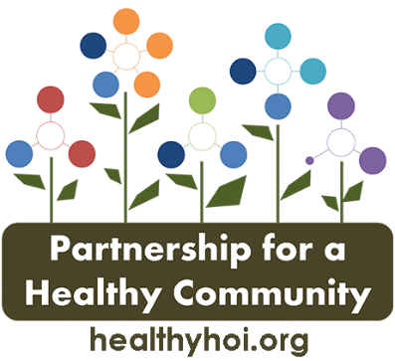

CANCER PRIORITY ACTION TEAM AGENDA
Date: Thursday, January 13, 2021
Time: 8:00 am to 9:30 am
Location: Microsoft Teams

Attendees: Andrea Ingwersen, Anne Bowman, Diana Scott, Melissa Goetze, Michele Scharping, Nicole Willenborg, Jessica Johnson, Jennifer Seils, Nicole Robertson, Kim Litwiller, Tom Cox, Jenny Chasteen, Olivia Pasol, Amanda Smith, Melissa Bucklin,

Topic | Leader | Action Items
Welcome & Introduction- (10 minutes) | Andrea Ingwersen | -Welcome to 2022!  -Meeting schedule – has not been posted to the website yet but will be continuing with the 2nd Thursday at 8am. Next meeting will be February 10th.  -Marketing plan meeting – moving forward health departments are going to take turns for who the lead PIO is and this should streamline the process. Need to be approved by the board then will be able to utilize logos and other marketing supplies to be able to make the process smoother.
Data-(10 Minutes) | Amanda Smith | -CHNA update – has been completed and is being worked through. Will then be able to set priorities for the tri-county area.  -no updated data as the data committee is working on the data for the next cycle.
Colorectal- (20 minutes) | Diane Hahn | -no Colorectal updates
Lung Cancer – (20 minutes) | Andrea Ingwersen | -January-Radon Action Month Public awareness campaign. Utilized the previously used Facebook posts to go out on the partnership and Woodford county health department page to educate about radon, risk factors, and importance of testing your home. Also included where to get test kits.  -Passive mitigation letter-Edits & next steps – goal is to gather data and some public awareness as the installation of passive mitigation systems in new construction has been a law since 2013. Idea to have a form that would be filled out and sent to a general email that would be for the tri-counties. Kim will work with Melissa on the form and email. Olivia will work on a more condensed informational flier to send out to residents.  -ITFC grant – still working on policies and conversations with business owners. Compliance checks are moving forward. Andrea created the community champions certificates with the business name on it. Businesses are then able to display these certificates for customers to see.  -Edwards grant – Kim did an interview about radon the first week of January. Hult center is still working on getting Asthma awareness in the school and working with Illinois Lung about the kick asthma program. Also working on virtual programing to reach all students about asthma education.
Breast Cancer- (20 minutes) | Tom Cox | -Screening Statement-Edits & next steps – would like to have contact information for people to be able to reach out to schedule screening appointments. Send the contact information to be used to Diana. Andrea will send out after edits have been made.  -OSF – has been doing a lot of genetic screening and due to this there has been a 62% increase in the high risk breast clinic. Looking at expanding the genetic screening and the high risk screening program. Screening volumes have stayed strong during the latest Covid surge. Breast cancer survivors retreat in April and actively recruiting a couple breast surgeons as well. Continuing to do marketing to keep people engaged in screenings and planning a screening event for the first 3 months of 2022.  -Michelle – will be promoting all screenings. Community events discussion about a spring event.  -UPH – first girls night out is March 16th and have started seeing some no shows but screening volume is staying relatively consistent.
 |  | -ACS in partnership with UIC cancer center are submitting an application for grant funding to propose an active role in the state. End of January is the date. Proposed to expand a state level coalition and have some fully integrated cancer prevention.

