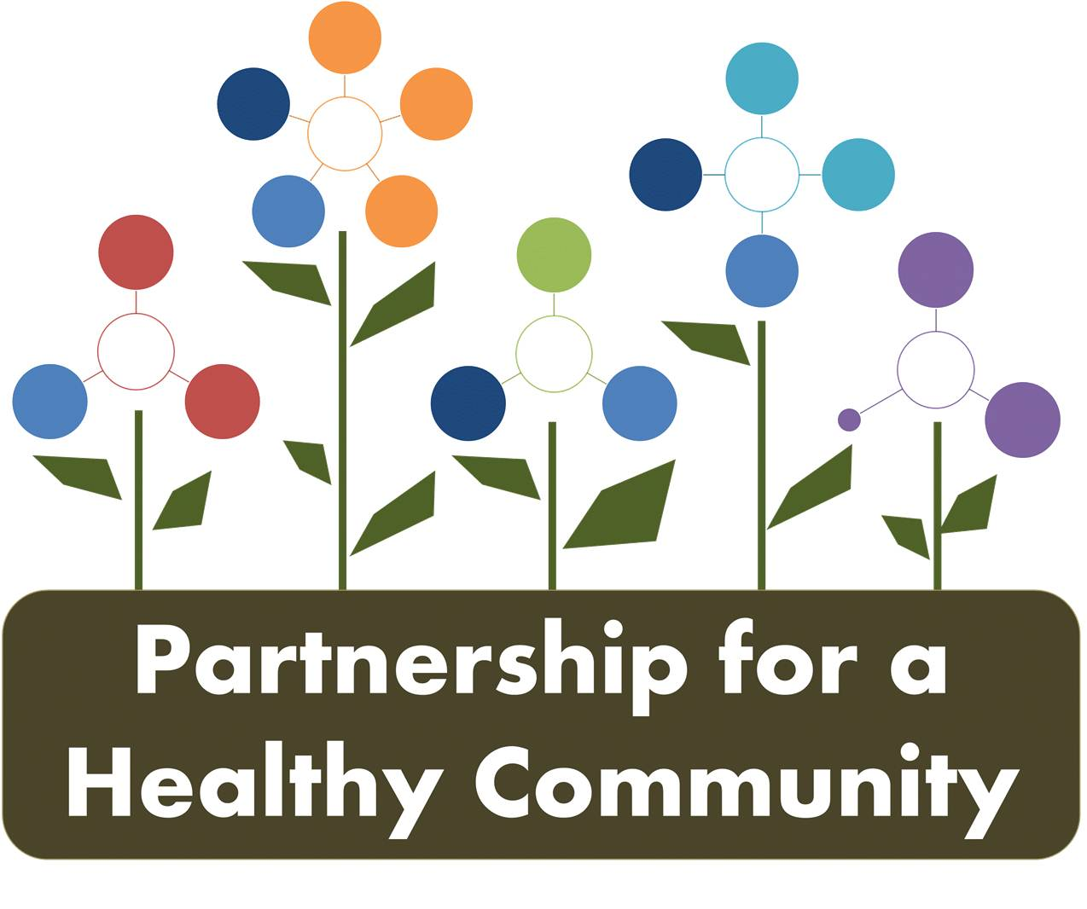
Breast Cancer Committee Meeting
Woodford County Health Department
November 13, 2018
1:00-2:30
In attendance:
Greg Eberle-Hopedale Wellness/Medical Complex
Donna Long-Unity Point Health Methodist
Gayle Young-Susan G. Komen
Andrea Ingwersen, Woodford County Health Department
Diana Scott-Peoria City/county Health Department

Minutes:

Review of October Awareness Events (this list is not all encompassing, just some examples of events when discussing join efforts):

-Dream Center, 2 events (IBCCP)
-Connecting women to services
-Friendship house events (Unity Point also)
-10/19-Mammo Day-40 women served; 13 at Proctor location. First year multiple locations
-Komen/TCHD shared booth at Women’s Lifestyle Show-IBCCP enrollments
-Grace Baptist Church (Peoria, by Carver Center)-IBCCP enrollments
-Pink Sunday Events
-TCHD/IBCCP and Unity Point-good job at church outreach, lots of collaboration and face-to-face interaction. Face-to-face interactions/outreach education is key to reaching different populations of women in greater Peoria area.
-Gayle reported distributing information to approximately 20 churches regarding hosting a Pink Sunday evet, wheat it is, etc. She is researching what Pink Sunday events look in other areas nationwide.
-The group discussed improvements for next October. All agreed IBBCCP did a fabulous job, lots of nights and weekends. And because of the committee, conversations took place before October on how to coordinate efforts, connections made, etc.
-The only improvement (from this committee, not individual member efforts) moving forward , regardless of outreach would be consistent branding and marketing of materials that are specifically form the Partnership for Healthy Community. Greg informed the group that the partnership board has discussed at length, that moving forward, agencies will commit to the Partnership through formalized MOUs and there will be a structure across initiative and committees.
Proclamation review, and distribution plan:

-Conversation regarding proclamation-decided to call it a “positon statement” instead. Minor changes to be made and another rough draft will be presented to the group for feedback.

-Gayle wrote the text of the position statement, referencing support of nationwide sources for starting the conversation for patients to screen and when to start screening. Komen as not included as Komen Memorial supports the Partnership stance and work but not what Komen recommends nationally.

-Andrea created the letterhead, and will make changes for the next rough draft to be presented to members to finalize.

-Distribution of position statement was discussed, should it be a news release or present at Partnership Annual meeting? As with listing the BC committee agencies, decided it would create more impact if presented at annual meeting; a news release for the position statement, sent to from the committee may not get attention from local media. Presenting at the annual meeting will link the committee to partnership, as a piece of the greater whole.

-Media contact was discussed, how to handle as a committee when position statement is distributed and if specific questions should occur. Greg will discuss with the board as Partnership Annual meeting is being planned, perhaps it should be the chairperson of each committee or there should be a media liaison for the Partnership as a whole. Greg will add that feedback to the board when marketing discussion occurs again.

-Gayle stated if questions were brought up specifically regarding the position statement and breast cancer, she would be comfortable talking to the media as a representative of the committee. After position statement is finalized, can be added to blog or BC portion of Partnership website and FB page.

-Discussion ensued about partnership website, the purpose (outreach to agencies or public) and responsibility of updating membership. This circled back around to responsible person for marketing of Partnership overall.

2019 Schedule and moving forward as a Committee

-Greg explained timeline of prioritization, now that CHNA surveys are completed. Data should be coming out the first of 2019, with prioritization conversations and meetings happening in spring of 2019. New prioritization plan will begin in 2020.

-All members in attendance would like to see BC committee continue of not a priority, as group work, and connections made have been successful. Other coalitions such as IBCCP could utilize the Partnership BC committee moving forward as well as many members are the same, to streamline meetings and work that is the same. Gayle noted that she is to host next IBCCP Coalition meeting at Komen offices, and she will discuss with Kim G. about combining groups.

-Diana noted that is what Illinois Tobacco Free Communities grantees (Peoria, Tazewell and Woodford) do for requirement of grant to have a coalition; utilize lung cancer committee as the coalition. Why duplicate efforts?

-New member discussion is tabled until next meeting. Meeting schedule to stay the same for 2019. Greg will follow-up to invite a representative from American Cancer Society to the quarterly meeting

Review and discuss current dashboard (10-29-18) and 90 day implementation:

- 2b&c-Eureka and Hopedale? Access?

4-BC mortality for tri-county area. Use 2015 data as baseline. Gayle will provide.

Announcements:

*Will continue review of dashboard and 90 day implementation at next meeting, ran out of time.

*Donna Long provided the group with materials from Unity Point’s new high risk clinic. Please contact her if you would like copies.

Next Meeting:
Quarterly Breast and Lung Cancer Committee-December 18th-Tazewell County Health Department 2:00-3:30pm
Health Department Conference Lines for call in participants are as follows:
*use the conference call number for the corresponding host site for each meeting
PCCHD number 866-588-5540, Code 556-971-0901
TCHD number 309-670-0444, Code 555
WCHD number 605-468-8004, Code 658044#

