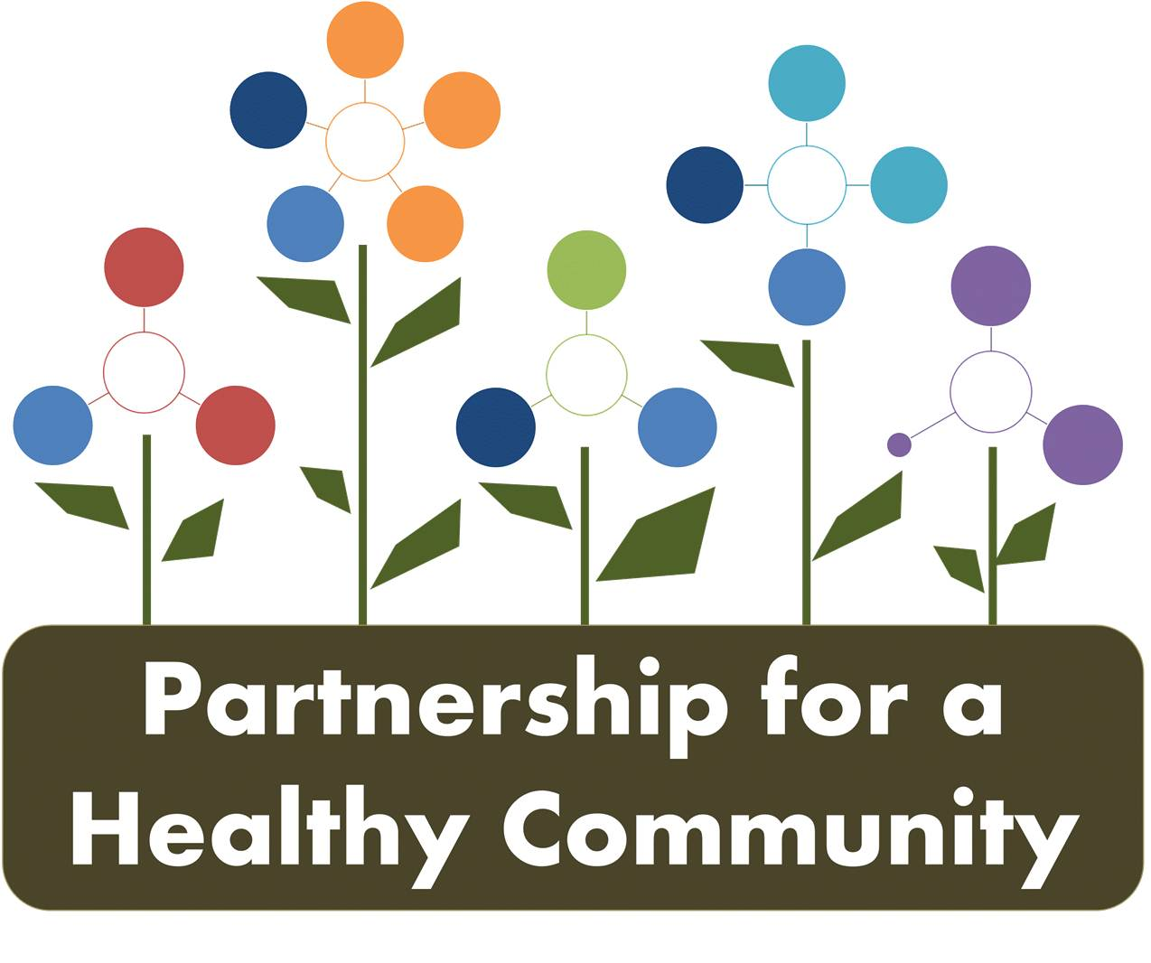
Healthy Eating Active Living (HEAL) Implementation Team
February 9, 2017
Attendees: Kathy Simpson, Beth Beachy, Erin Stout, Shanita Wallace, Lexie Schwartz, Debbie Stark, Margaret Cover, Adrienne Southerland, Vicki Turner, Hillary Aggertt, Morgan Casey, Mary Ardapple
The meeting was called to order at 2:00 pm. The group was welcomed to the team and introductions were made.
Kaitlyn and Adrienne (team co-chairs) reviewed the goals and objectives of the group as outlined in the Tri-County Community Health Improvement Plan.
The team was then divided into two groups, focusing on youth and adult and encouraged to brainstorm current activities and programming in the community.
Youth:
- CATCH Program currently offered through
  - Tazewell County Health Department (18 after school programs)
  - Hult Center (District 150 Schools-2 schools every 3 years; Glen Oak & Harrison currently)
  - Bright Futures (through Hult to train teachers)
  - Peoria County Extension (agencies and after school)
- Extension offers a Cooking with Teens in Peoria County-low income, summer program
- Extension focuses on 61605 zip code (low income schools)
- Bright Futures has a health educator that goes out
- Extension offers ABC School Nutrition-offers an assessment of is the healthy choice the easy choice, then helps with interventions, including financial support to make changes. They train the food service staff and provide direct education in the classrooms. Available to any school in Illinois.
- Fresh fruit/vegetable grants through USDA
- Hult Center offers the Healthy Classroom Initiative—offers pre and post tests and then educate on two lowest levels from the pre-test. Classrooms can take field trips on health to the Hult Center for 5th grade and below. For high schools they focus on more puberty and drug education.
- WIC (all three counties)-struggling with caseload issues. Nutrition education provided during certifications and follow up appointments as well as secondary education through group classes, online classes and self study modules.
- WIC Farmers Market Nutrition Program (Peoria & Tazewell)-low redemption rates.
- Harrison School has a door decorating contest around My Plate
- There needs to be policy and environmental change.
- With the education system, we need to get administration on board with education.
- We need to link efforts to data.
- Woodford County Schools have so many unfunded mandates.
- Parent associations are a good place to start.
- Focus areas: access, knowledge, convenience and stigma.
- Who do we need to recruit? School food service.
- Hillary is going to speak at Metamora High School on February 28.
- Rock Island Bike Path.
- We need to change the norm and CELEBRATE the achievements.

Adult:
- Engagement- getting people into motion
- Leap into Wellness program for Adults
- Blood Pressures at Churches- Million Hearts Initiative
  - Washington United Methodist
- Municipal challenges such as Peoria City vs. Peoria County
- Illinois Valley Striders- working to get people moving
- Janelle @ Proctor offered the Proctor Center
- Community Walking Calendar
- Develop Location list: where you could be active
- Buddy program: youth and adults work together, adopt a neighborhood, cub scouts, girl scouts, youth groups
- Who is promoting, liability, disclaimers- at- risk for protection?
- How do we incorporate healthy living? Cost of Food? Donations, funding and Sponsors.
- Broad base Awareness campaign- branding and tagline “ Communities in Motion”

Due to lack of time, we did not reconvene to share between the groups. We will share at the next meeting, which is scheduled for March 9, 2017 at 2:00 pm at Tazewell County Extension Office in Pekin.

